Focused Annotation:

For focused annotation, you need to have both Vast and Omni open. You will need to use the Virtualbox.
-Boot your workstation in Ubuntu if not already in Ubuntu. If in windows, restart your computer. It should boot automatically into Ubuntu. If it boots into Windows, hold f12 once you see the Alienware screen. Be sure to mount your data after every reboot.
-Once in Ubuntu, click on the portal icon on the top of your icon list.
-Start to type VirtualBox until it appears and open it. Hit the start button on the VirtualBox window.
-Once the VirtualBox loads, open the VAST icon on the Windows desktop.
-Open the EM that you intend to work on.
-Open omni by typing “Omni” into a new terminal. Depending on the data, you may need to type “sudo omni” and enter your password.
-Once Omni is open, go to file, and open the .omni file that you intend to use. Depending on the file, it may ask you to choose a username. For Focused annotation, it’s better to work with the raw set, so choose “Default”.
-Once the file is open, make sure to follow the normal protocol for starting an Omni project: Select the dual-screen icon from the tools list at the top of the screen. Select the “segmentation” channel to make the segments appear. Change the “Global Threshold” to 0.3.
-From here, you will want to chose segments down the list and look for trouble spots, ignoring glia, somas, and blood vessels.
What you are looking for:
When looking for trouble spots, you will want to make sure you are selecting the right type of errors. Mergers or broken neurons are the chief concern. By broken neurons, we mean any instance where the AI stopped following the growth of a neuron. This includes detached dendritic spine heads and discontinued axons. 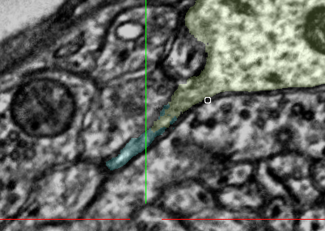
Pictured above is an example of a detached dendritic spine head.
-Once a trouble spot is located, you will want to annotate the neurons involved for the space and number of slides that contain the issue.
For Example: In the situation of the detached spine head pictured above. You would:
-estimate a mask area that will fully encapture the area where the AI first failed to follow through the segment.
-next, you will completely annotate the neuron in question, as well as part of the surrounding neurons that lie within your estimated mask area. Using the L key is very helpful in this step. It allows you to toggle the color segmentation so that it is easier for you to see where the border is, and so where you should not be coloring.

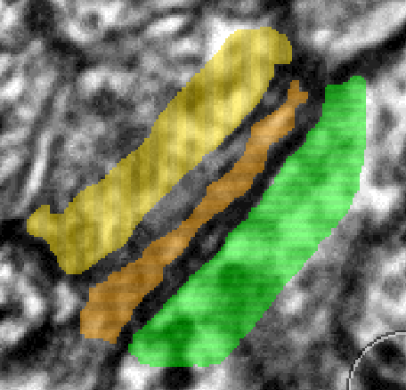

-Once that is done, you will chose another segmentation color and color the border of the neuron in question. For this example, the color will be red. The easiest way to execute this step is to increase your cursor size and to run it over the other neurons so as to get most of the border in one stroke. You can’t color over the color you already chose for the neuron itself, so don’t worry about that. For this example, the edges not bordered by other segments require more careful work.
-There are a few spots where small sections of extracellular space make finding and annotating the border confusing. This next image will point some of them out.
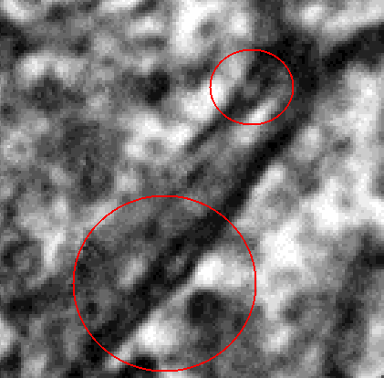
-These are pockets of extracellular space within the border. We are to fill these in as part of the border.
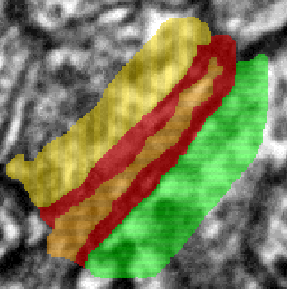

In the image above, I have colored in the perceived border of the neuron.
-Next you will want to apply the mask. This will be done with a separate segmentation. The mask should enclose everything you have annotated up to this point.
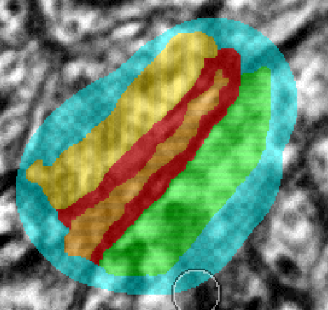
-At this point you have finished your focus annotation. Wooo!!



